22.May.2023

To,
Drug Controller General of India
Directorate General of Health and Family Welfare,
Government of India,
FDA Bhawan, ITO,
Kotla Road, New Delhi-110002

UNDERTAKING

We {manufacturerName} having registered office at {manufacturerAddress} do hereby declare and undertakes that all the facilities required such as equipment’s, instruments, personnel and other resources are being provided at our manufacturing setup for the manufacturing of applied product.

Thanking you

Yours truly,
{manufacturerName}

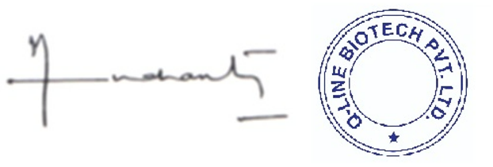
{directorName}
Director

